

| Course Number | COE328 |
| --- | --- |
| Course Title | Digital Systems - F2022 |
| Semester/Year | Fall 2022 |
| Instructor | Shazzat Hossain |
| TA Name | Sajjad |

| Lab/Tutorial Report No. | Lab 4 |
| --- | --- |

| Report Title | **VHDL for Combinational Circuits and Storage Elements** |
| --- | --- |

| Section No. | 11 |
| --- | --- |
| Group No. | N/A |
| Submission Date | December 2, 2022 |
| Due Date | December 3, 2022 |

| Student Name | Student ID | Signature* |
| --- | --- | --- |
| Hamza Malik | 501112545 | Hamza Malik |

*\*By signing above you attest that you have contributed to this submission and confirm that all work you have contributed to this submission is your own work. Any suspicion of copying or plagiarism in this work will result in an investigation of Academic Misconduct and may result in a “0” on the work, an “F” in the course, or possibly more severe penalties, as well as a Disciplinary Notice on your academic record under the Student Code of Academic Conduct, which can be found online at:*

[*http://www.ryerson.ca/content/dam/senate/policies/pol60.pdf*](http://www.ryerson.ca/content/dam/senate/policies/pol60.pdf)

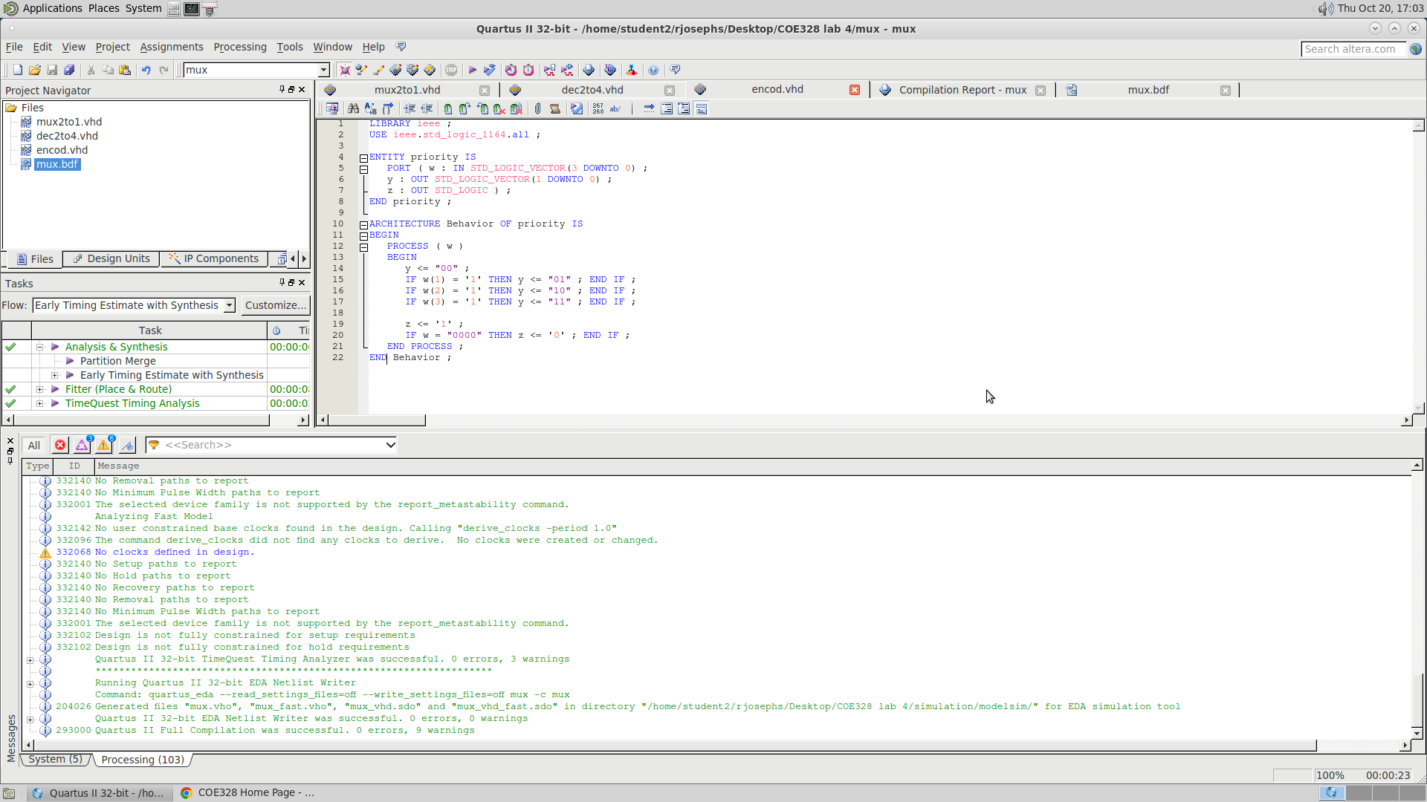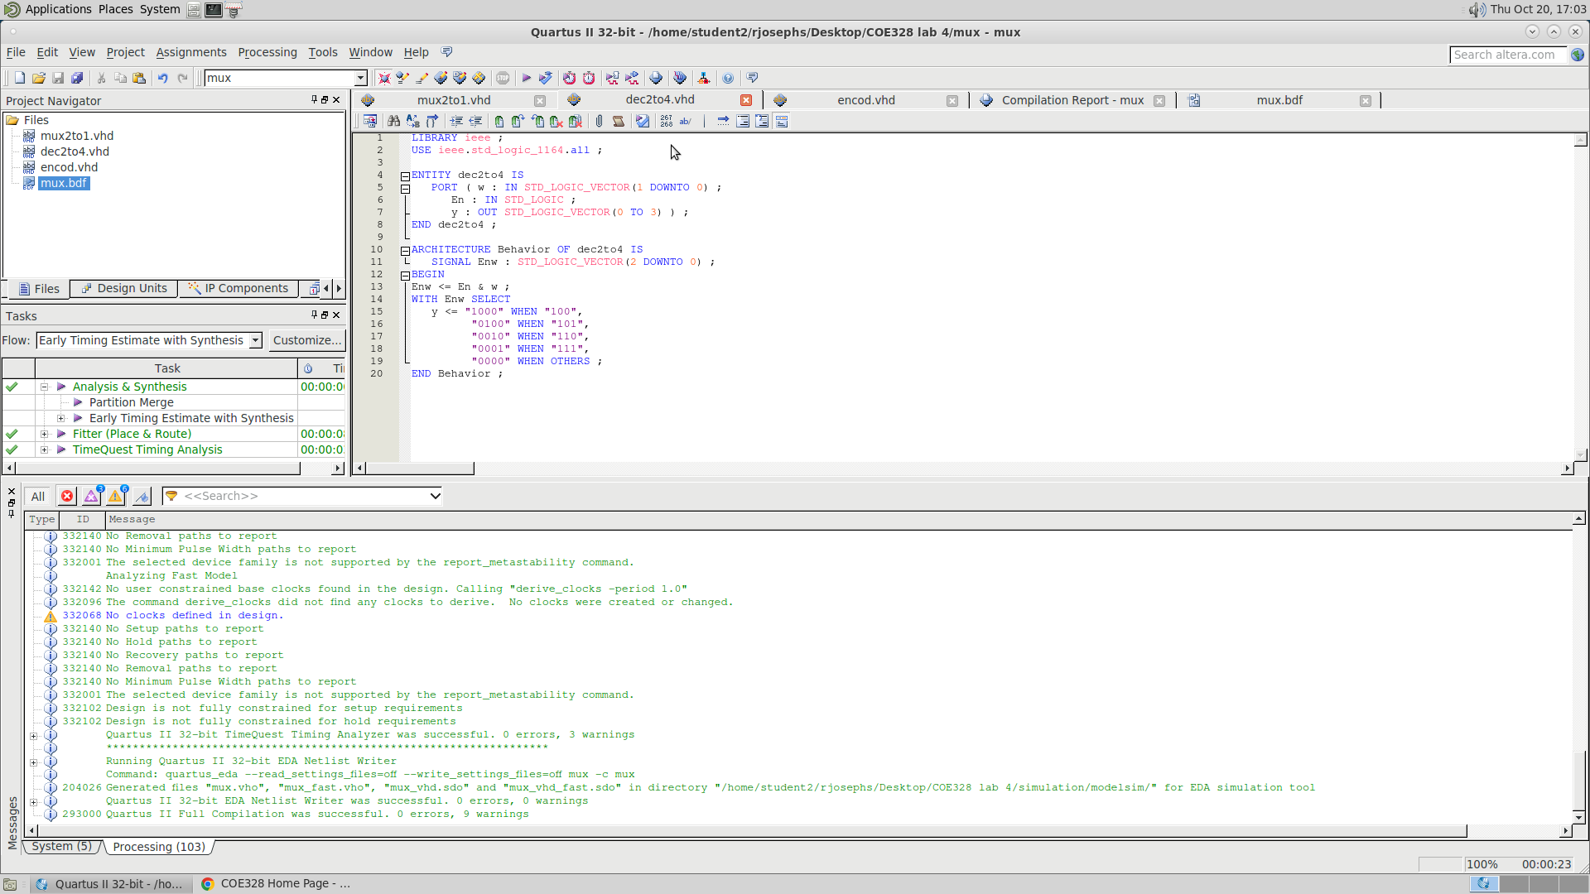

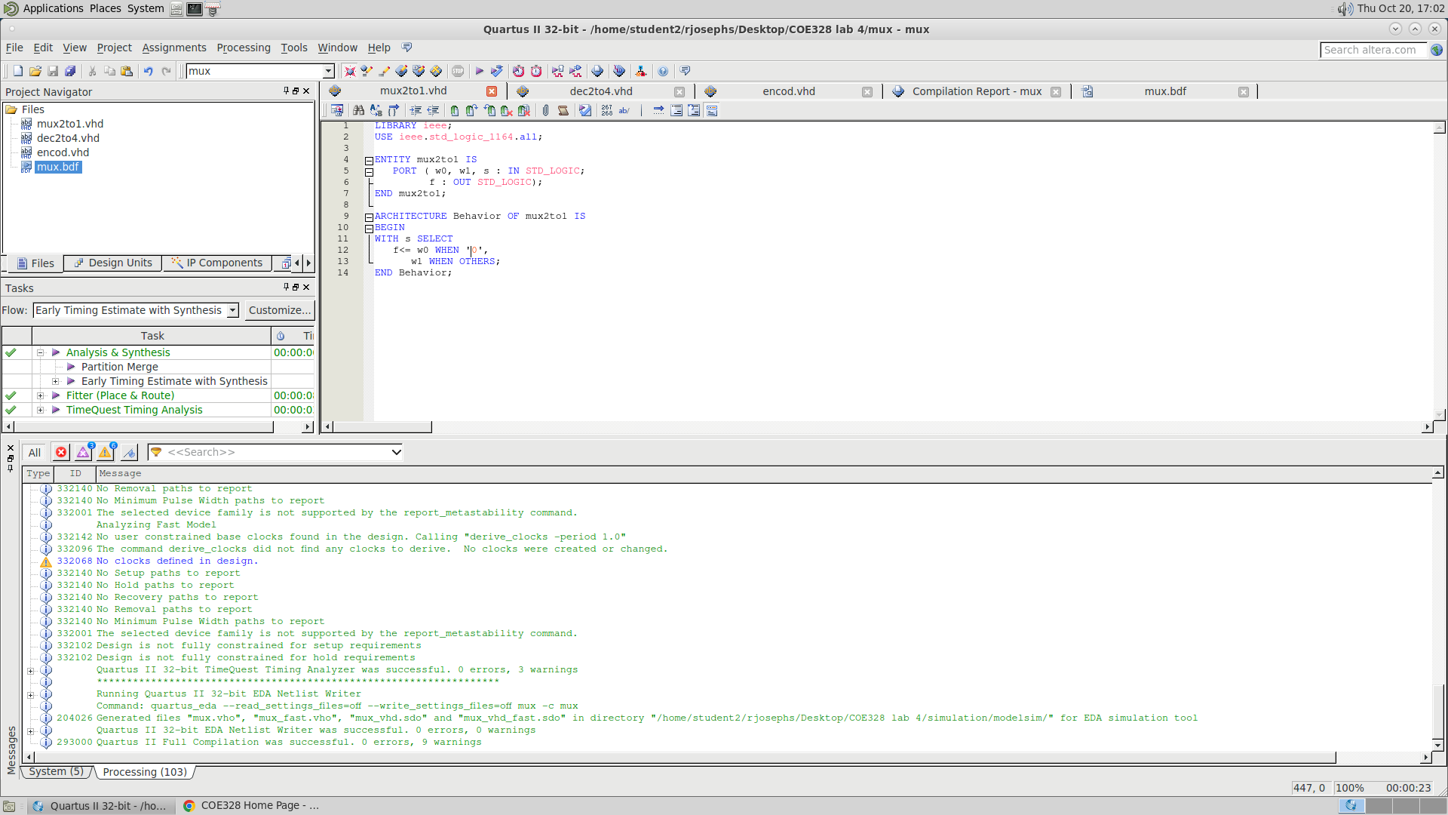

This is the VHDL Skeleton code for lab4 part 1 coe328 created during our lab 4 week 1 with the custom function.

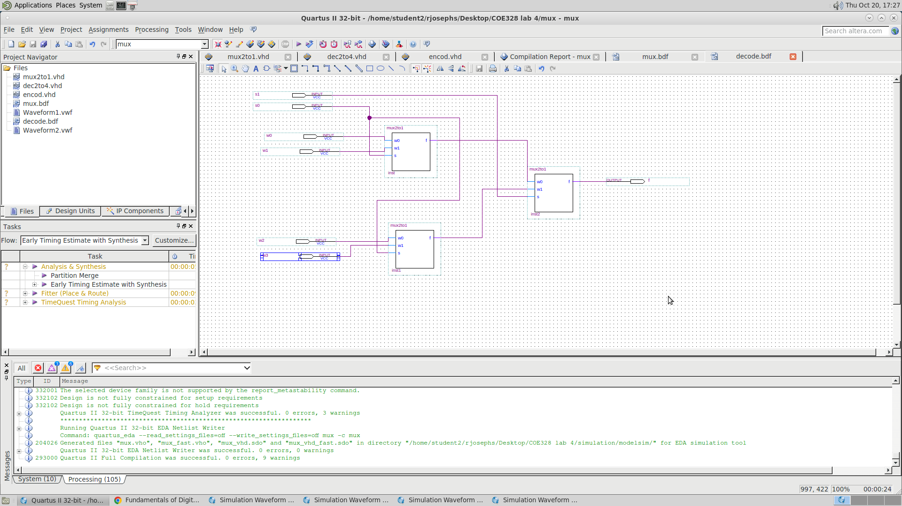

This is our block diagram schematics symbol made using the vdhl code for lab4 part 1

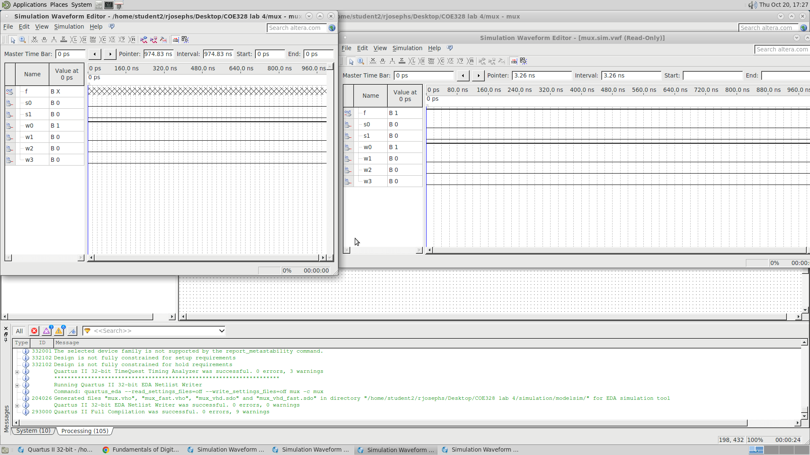

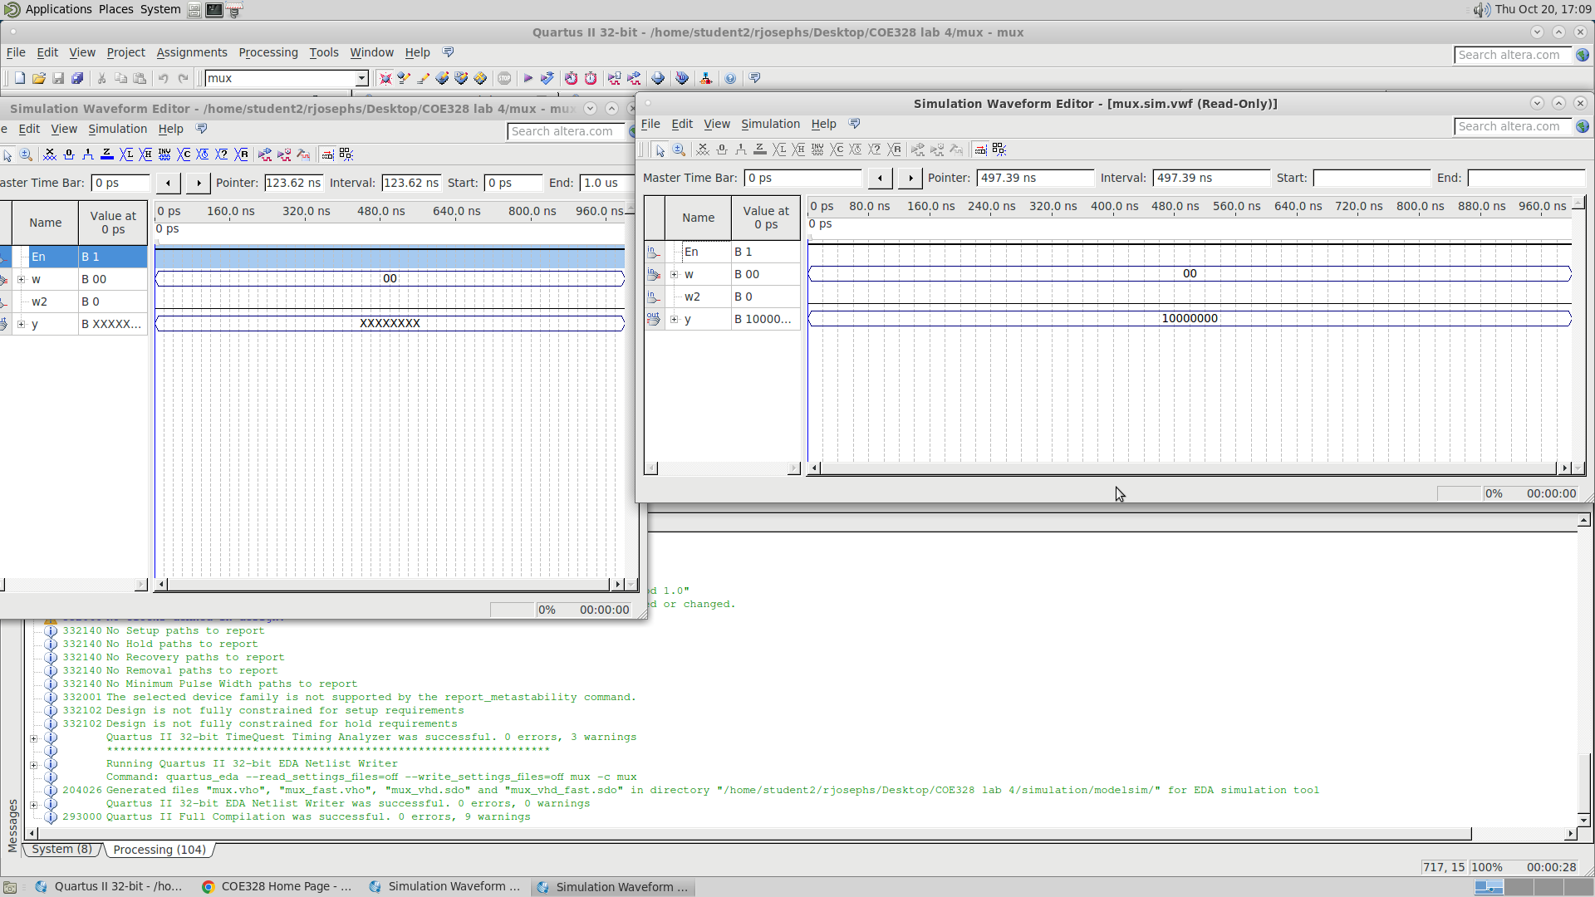

This is a picture of our waveform diagram created with the VHDL code for lab4 part 1.

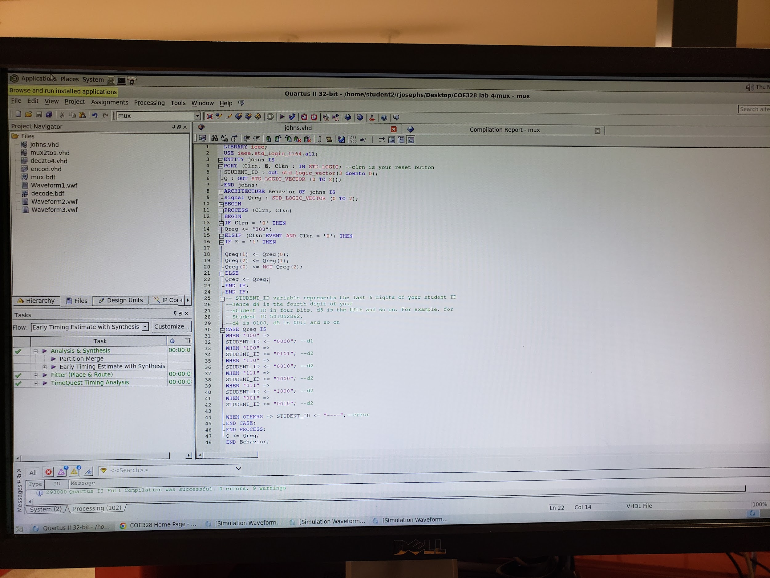

This is the VHDL Skeleton code for lab4 part 2 coe328 created during our lab 4 week 2 with the custom function.

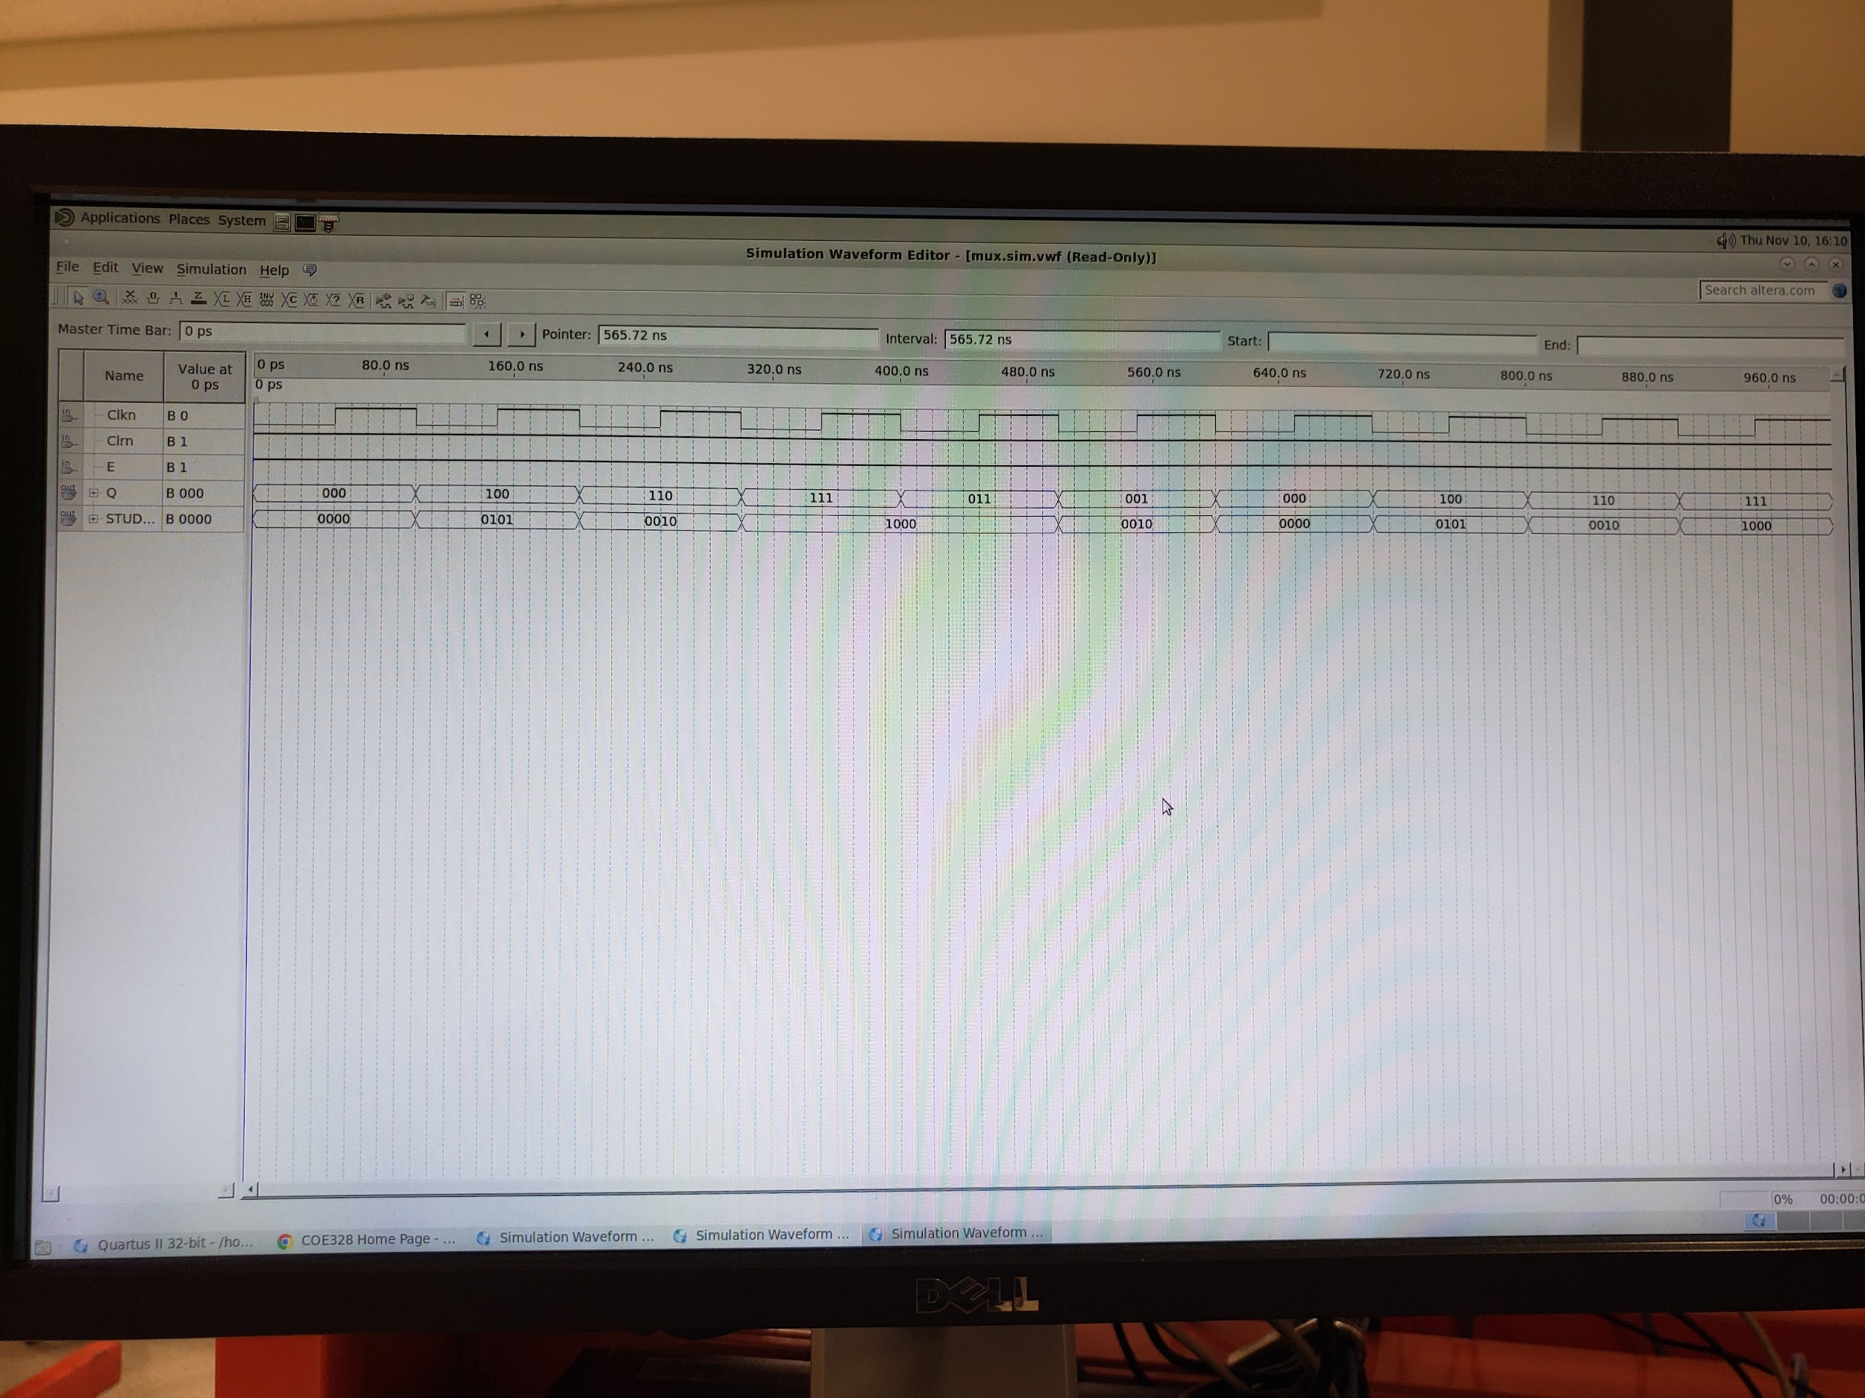

This is a picture of our waveform diagram created with the VHDL code for lab4 part 2.

**Conclusion:**

To wrap up our lab 4, we constructed combinational circuits and circuits with basic storage elements. The lab was broken down into 2 weeks, for the first week we used subdirectories from our prelab to implement our vdhl code with our student numbers then implemented 4:1 multiplexer using two 2:1 multiplexer and got our overall waveform output. For the second week we implemented the Johnson counter with our student number, got the vdhl code and the overall wave form output.